**B.C.M. Sen. Sec. School, Basant City, Pkh. Road, Ludhiana**

Name ___________________ Roll No._____ Standard I

Chapter ( 2, 3 )

1. **Match the following by filling the same colour.**

**Play games**

**Railway Station**

**Print bills**

**School**

**Book tickets**

**Home**

**Teach**

**Shop**

1. **Look at the pictures given below. Mark them with Green star if a computer can do the task and with Red star if computer cannot do the task.**

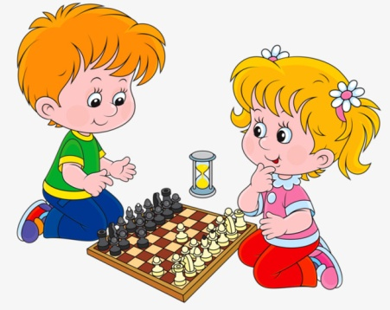 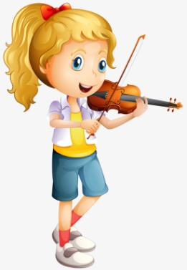 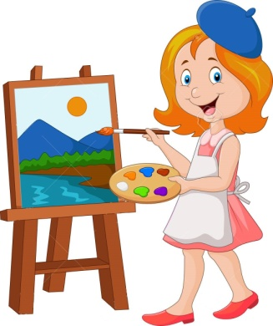  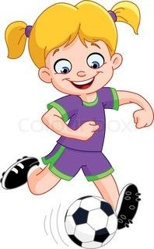 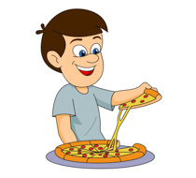 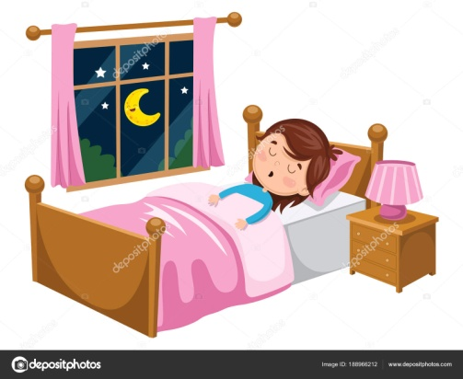 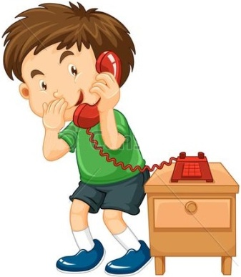 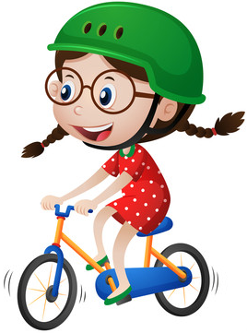

 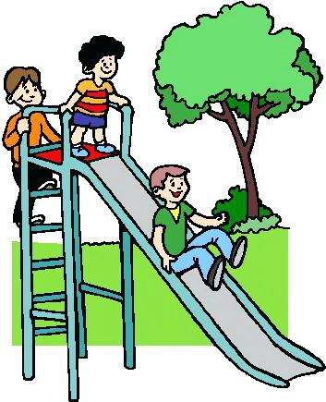 

1. **Observe the activities on the monitors and join them with the correct labels below.**

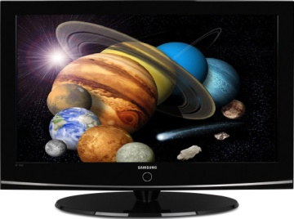 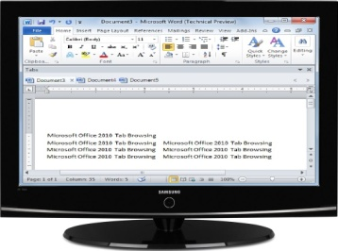 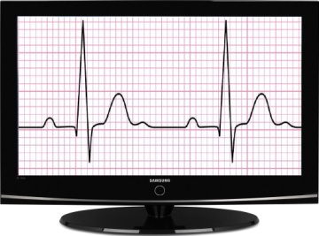 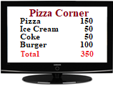

**Office**

**School**

**Hospital**

**Restaurant**

1. **Answer the following questions.**
2. **Name the places where you have seen computers.**

**Ans. Home, School, Restaurant, Office, Railway Station, Airport, Hospital, Shop.**

1. **What are the main parts of a computer?**

**Ans. Monitor, CPU, Keyboard, Mouse.**

1. **Name any two games that you play on computer.**

**Ans. Chess, Car Racing.**

1. **What are the uses of a computer?**

**Ans. Play games, type letters, draw pictures, watch movies, listen to music, solve sums.**

1. **Which computer part has a tail in it?**

**Ans. Mouse**

1. **Match the following:**

|  |  |
| --- | --- |
| Image result for cpu | Image result for television |
| Image result for monitor | **C:\Users\kj\Desktop\www-anatomy-of-brain-lateral-view-the-kenhub.png** |
| Related image | Related image |
| Related image | Related image |